## **CREATION OF CLOUD OBJECT STORAGE SERVICE**

|  |  |
| --- | --- |
| **TEAM ID** | PNT2022TMID24852 |
| **PROJECT NAME** | IOT BASED SMART CROP PROTECTION SYSTEM FOR AGRICULTURE |
| **DATE** | 18/11/2022 |

IBM Cloud provides solutions that enable higher levels of compliance, security, and management, with proven architecture patterns and methods for rapid delivery for running mission-critical workloads. Create a cloud object storage service, create a bucket to store the images, and configure the bucket settings

**STEP 1:**

• IBM cloud account creation.

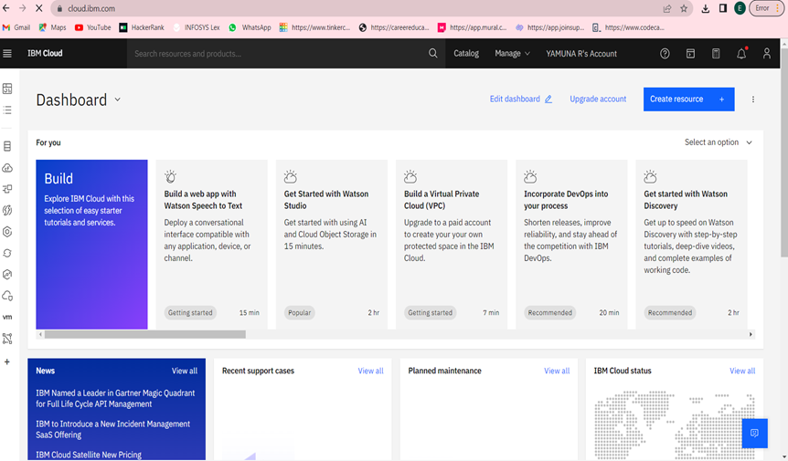

**STEP 2:**

• Choose object storage from the storage under services and give the service name and click create option.

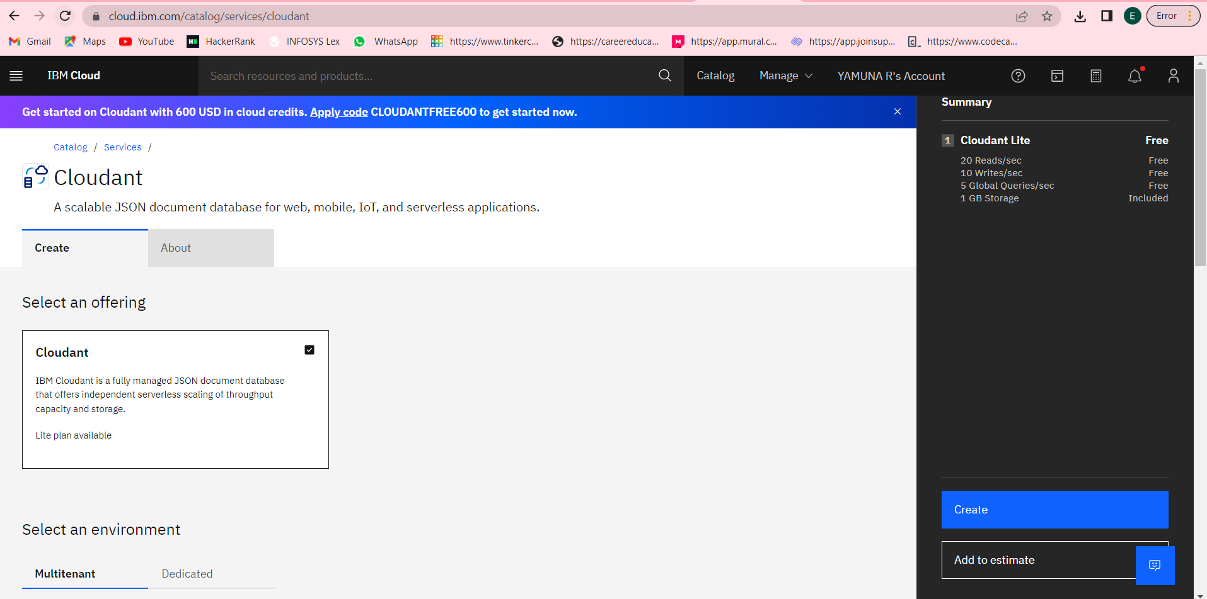

**STEP 3:**

• Creating a bucket to store the files and data.

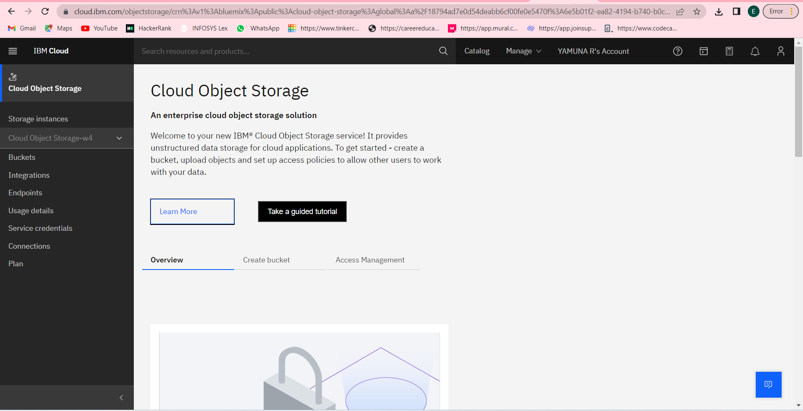

**STEP 4:**

• Creating a bucket to store the files and data.

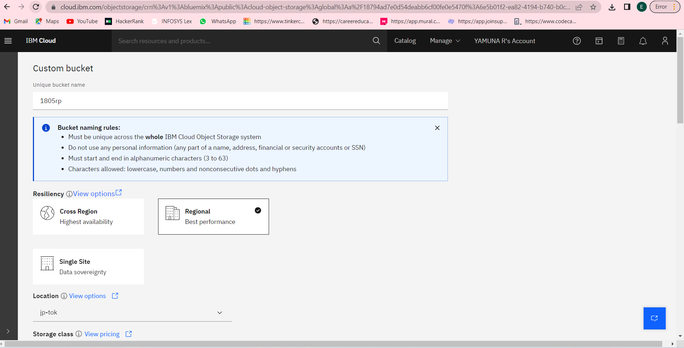

• After creating a bucket, we can upload the files needed.

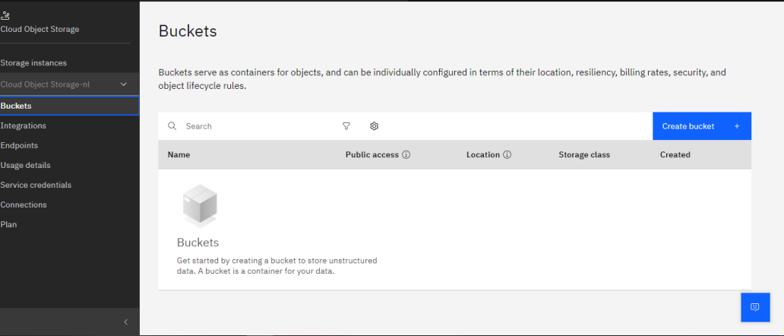

**STEP5:**

• Creating the access policies.

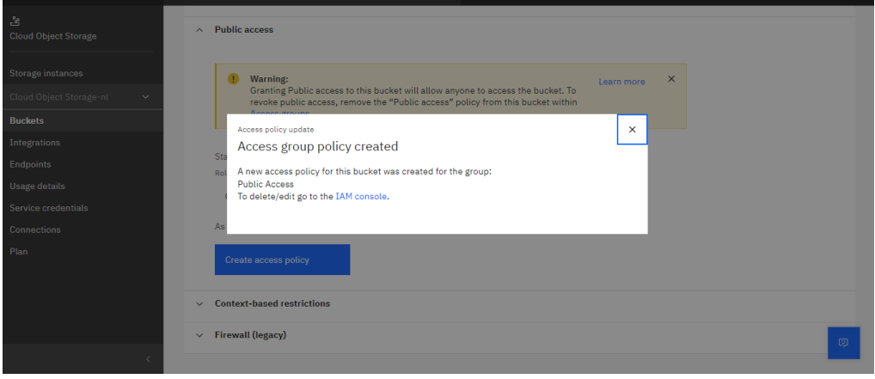

• Public access is given to the bucket.

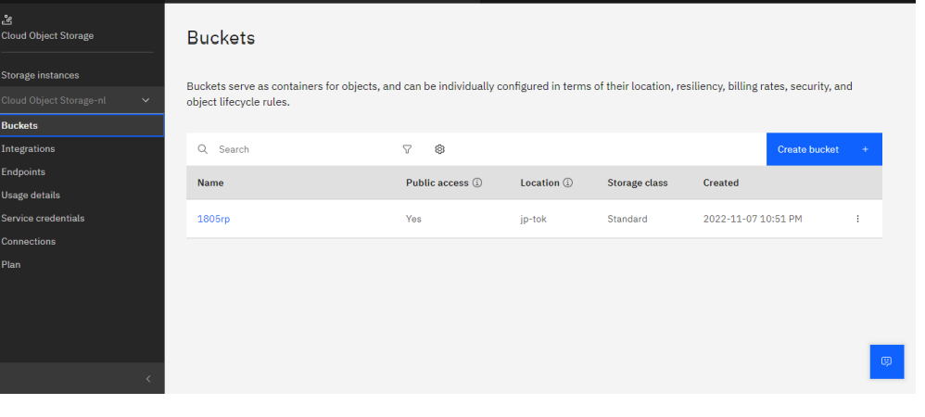

•Accessing the service credentials

